# GetSessionAttributeStep

**Objective:**

It is used to get attributes by using key

**Attributes:**

|  |  |
| --- | --- |
| **Attributes** | **Description** |
| keys | Used to enter key to get attribute |
| value_type | To select type as free marker template or handlebar |
| output_variable | Used to store the response of the request |

**Sample config.json:**

{

"workflows": [

{

"name": "get_session_attribute",

"id": "get_session_attribute",

"trigger": "rest",

"expression": "/get_session_attribute",

"method": "GET",

"steps": [

{

"id": "1",

"type": "session-get-attribute",

"value_type": "hb",

"keys": [

{

"key": "Name",

"value": "vinay"

}

],

"output_variable": "out",

"next": {

"success": "sess_succ",

"failure": "sess_fail"

}

},

{

"variable_name": "out",

"http_response_code": "200",

"response_content_type": "application/json",

"value_type": "hb",

"type": "send",

"id": "sess_succ",

"next": {

"success": "hangup",

"failure": "hangup"

}

}

]

}

],

"filters": [],

"server": {

"session.cookie.name": "SESSION_ID",

"session.plugin.type": "jdbc1"

},

"plugins": [

{

"id": 1422,

"name": "jdbc1",

"type": "jdbc-session-plugin",

"version": "1.0",

"category": "Session",

"server": "dev-freetier.ctskr0ebzcrp.ap-south-1.rds.amazonaws.com",

"schema": "trigger_app",

"username": "appup",

"password": "appup123",

"cookie_name": "unibic",

"expireInSeconds": "240"

}

]

}

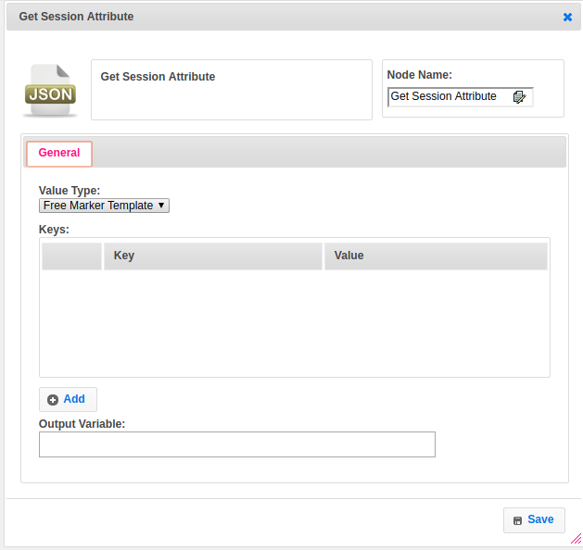

**Executor Description:**

In executor class it will get the attributes based on the keys which given by user then stores those attributes into output variable and returns step status as success.